App Development 1 Project: Quantified Self

Basic Requirements Completed:

* User login
* Dashboard and Trend lines
* Tracker management
* Tracker log events

1. User Login: Multiple user login system with password has been implemented using flask-login library. New user can also sign-up with a unique username and password.
2. Dashboard: The main dashboard appears after user login with all trackers created by the user which has links to other functionality.
3. Trendlines: All tracker types have a plot associated with it which can be filtered for custom duration of logging. It has been implemented using Matplotlib library.
4. Tracker management: trackers have all basic functionality like add a tracker, view tracker logs, update and delete a tracker. Implemented using flask library and sqlite database integrated using Sqlalchemy ORM.
5. Tracker log events: Trackers have logs added to database through relation and have all CRUD operations like adding a log, updating, deleting and viewing all log details.

Additional Functionality:

1. Styling and Asthetics: Bootstrap library has been used for basic styling of html.
2. API and export log function implementation is in progress.

Screenshots:

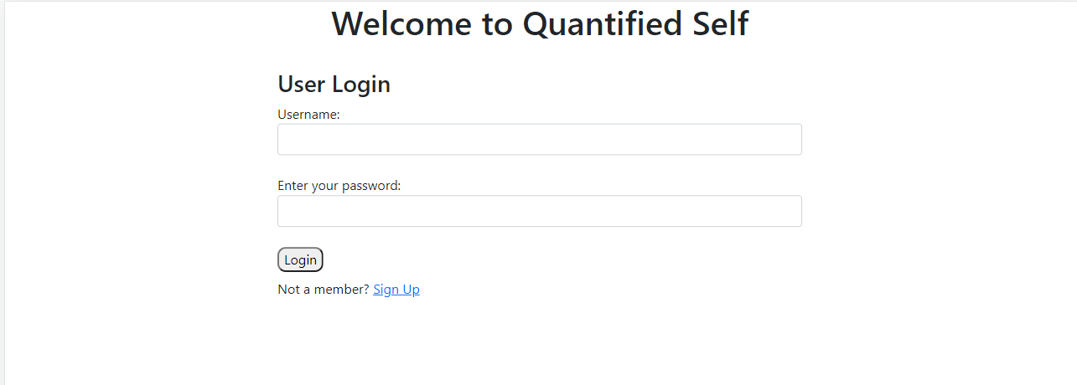

Figure Login screen

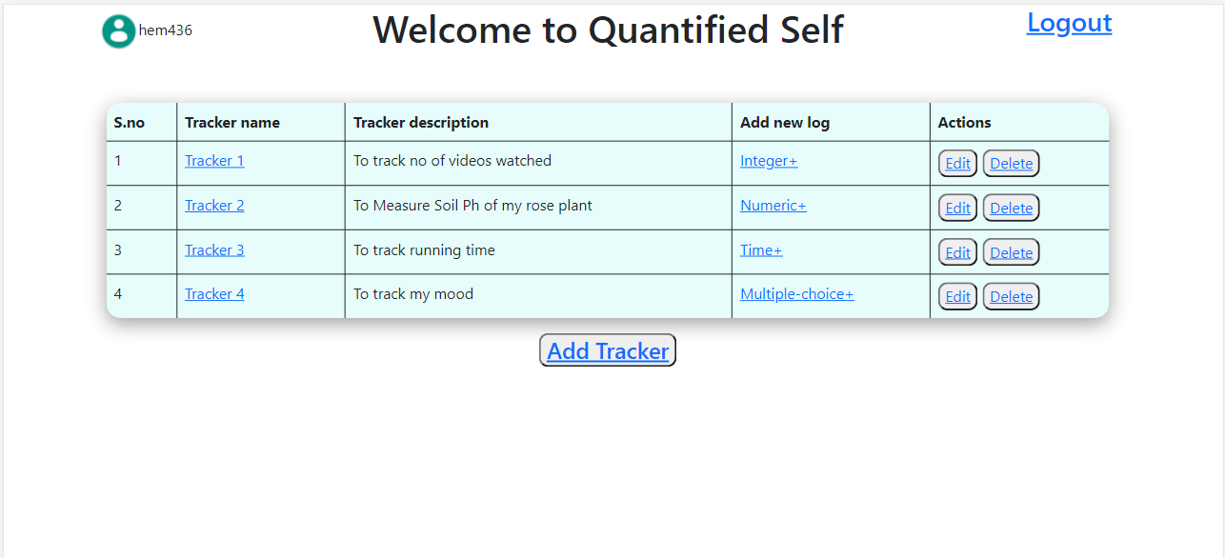

Figure .Dashboard

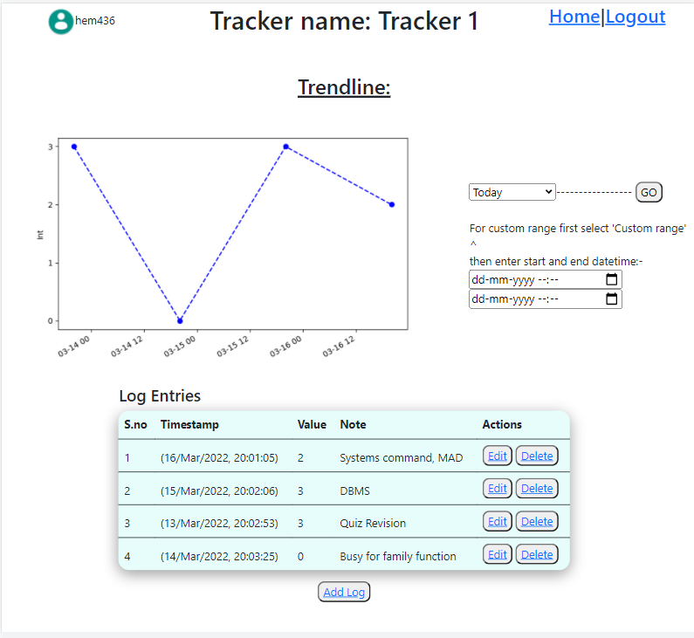

Figure Tracker Details